Software Requirements Specification

for

**Startup Initiative NU**

Version 1.0 approved

Prepared by Group No. 5

NIIT University>

<20/9/16>

Table of Contents

Table of Contents ii

Revision History ii

1. Introduction 1

1.1 Purpose 1

1.2 Document Conventions 1

1.3 Intended Audience and Reading Suggestions 1

1.4 Product Scope 1

1.5 References 1

2. Overall Description 2

2.1 Product Perspective 2

2.2 Product Functions 2

2.3 User Classes and Characteristics 2

2.4 Operating Environment 2

2.5 Design and Implementation Constraints 2

2.6 User Documentation 2

2.7 Assumptions and Dependencies 3

3. External Interface Requirements 3

3.1 User Interfaces 3

3.2 Hardware Interfaces 3

3.3 Software Interfaces 3

3.4 Communications Interfaces 3

4. System Features 4

4.1 System Feature 1 4

4.2 System Feature 2 (and so on) 4

5. Other Nonfunctional Requirements 4

5.1 Performance Requirements 4

5.2 Safety Requirements 5

5.3 Security Requirements 5

5.4 Software Quality Attributes 5

5.5 Business Rules 5

6. Other Requirements 5

Appendix A: Glossary 5

Appendix B: Analysis Models 5

Appendix C: To Be Determined List 6

Revision History

|  |  |  |  |
| --- | --- | --- | --- |
| **Name** | **Date** | **Reason For Changes** | **Version** |
| N | 20/9/16 | - | 1.0 |
|  |  |  |  |

# Introduction

## Purpose

The purpose of this web-based software is 3 faceted:

1. Create a platform which connects startups with interested students, based on their skillset and experience.
2. Allow students to find a co-founder for their startup or any help relating to their startup.
3. Allow students to access vital information regarding placements, interviews and their criteria’s.

## Intended Audience and Reading Suggestions

The intended audience is university faculty, placement cell, students, testers and marketing staff. There are no specific reading suggestions for this document.

## Product Scope

This web-based software has 3 main features:

###### **Create a platform which connects startups with interested students, based on their skillset and experience.**

Experience before graduating from university is what every company looks for nowadays. Likewise, many startups are looking for skilled engineering students to help them out. This gap is what this software intends to bridge.

###### **Allow students to find a co-founder for their startup or any help relating to their startup.**

It is very critical to find a cofounder and even more so to get help from experienced members of this college. This is what this software intends to help an entrepreneurial student do.

###### **Allow students to access vital information regarding placements, interviews and their criteria’s.:**

The benefits of this software feature are students getting better knowledge of the criteria’s relating to placements and interviews, the types of questions asked and the minimum requirements for different companies that visit the campus, thus increasing the chances of a student getting a job immensely.

The idea could very well be expanded to other colleges.

## References

No references

# Overall Description

## Product Perspective

This document contains the description of a software solution for solving 3 critical issues faced by university students: Help university students in placement interviews, providing a platform to meet cofounders and seek help for startup and Bridging the gap between startups and students seeking internship opportunities.

The website will have a user log-in system (both native and social network log-ins) and would have the feature of user profiles, wherein the users can display their skills, job experience, startups and other relating information.

It will have a notification feature for various types of user-notifications.

Along with this, it’ll also feature Direct-Messaging feature for inter-user communication and email notifications on the registered mail.

|  |  |  |
| --- | --- | --- |
| Use Cases | Objects | Description |
| UC1 | Look for internship | Allows user to search from the list of live internships |
| UC2 | Update internship information | update the details of the internship |
| UC3 | Make or maintain profile | Create or edit profile details of the user |
| UC4 | check or review profiles | check profile details of users |
| UC5 | Select company | User may chose a company for details |
| UC6 | Manage database | Allows admin to manage the database |
| UC7 | get eligibility criteria | Allows user to get the eligibility criteria for jobs at listed companies |
| UC8 | Interview question | Allows user to browse interview question asked at different company interviews |
| UC9 | additional help | Allows user to ask for additional help |
|  |  |  |
| UC10 | make or maintain startup profile | startup owners can create mantain profiles of their firms wherein they can also view profiles of students |
| UC11 | maintain database | the administrator constantly needs to alter the information there in the database to keep it afloat. |
| UC12 | moderate forum | the administrator can check users for their inappropriate behaviour and penalize them accordingly. |
| UC13 | direct messaging | teachers and students can directly message each other regarding a doubt/problem. |
| UC14 | help in idea | a person willing to be a cofounder of an entrepreneurial startup, can now start interacting with his co immediately |
| UC15 | discussion forum | a common platform for sharing knowledge. |
| UC16 | invest | enables a willing investor to invest in a startup of his choice |

## Product Functions

As aforementioned, this product has 3 main features:

1) Provide help to university students for placement interviews

2) Provide a platform for university students to find cofounders and seek help for startup

3) Bridging the gap between startups and students seeking internship opportunities

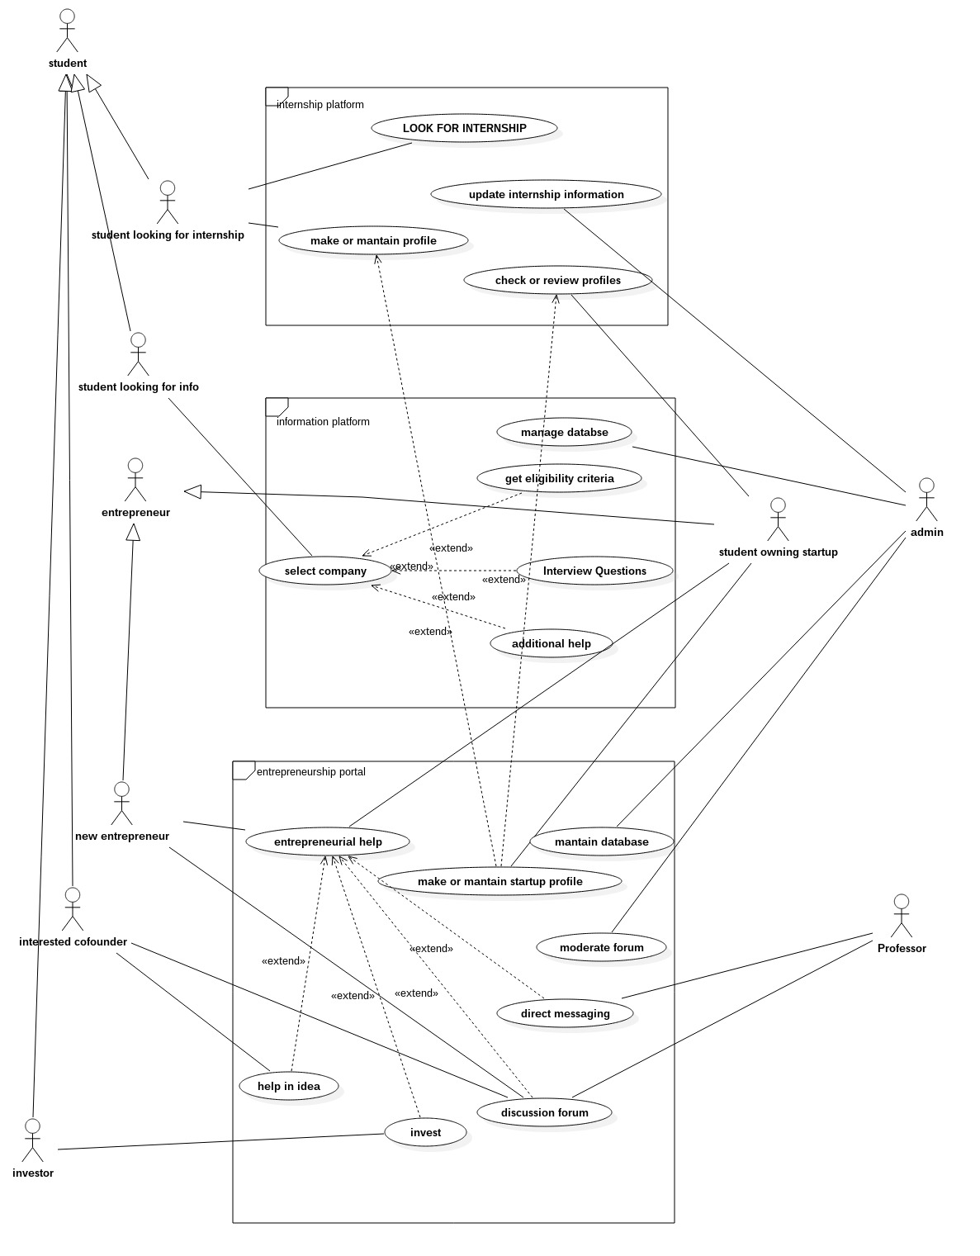

**Major Functions of the website:**

1. Authenticate and Login user to the website.
2. Enable new users to register to the Website.
3. Enable a registered user to change his password in case She/he forgets Hers/his password.
4. Enable a registered user to view his/her profile. Additional information viz. questions asked by him and answers posted by him are also displayed.
5. Enable a registered user to update his profile which includes her/his location, skills and profile picture.
6. Enable a user to view available internships
7. Enable a logged in add skills
8. Enable a logged in user to Add a Start-up profile.

## User Classes and Characteristics

There are 3 major classes of users : the first is the student , second the faculty and lastly the administrator of the system

It is necessary for the user to have a basic knowledge of operating the internet and have an access to it.

The administrator is expected to be familiar with the interface of the tech support system.

## Operating Environment

Chrome, Firefox, IE and Tor or any other modern browser supporting HTML5 and JavaScript.

## Design and Implementation Constraints

This system is provisioned to be built on the Django framework which is highly flexible. Decision regarding which database to use should be taken considering the fact that data being exchanged or stored is large, and the appropriate data management system will yield efficient performance.

## User Documentation

No user documentation required.

## Assumptions and Dependencies

## This software depends on the type and version of browser being installed in the system i.e. The browser version being used must have HTML5 and JavaScript support.

# External Interface Requirements

## User Interfaces

Each interactive part of software is made to be understandable and efficient for user. The software will be kept light so it does not take time to load and can handle large number of users properly

<Describe the logical characteristics of each interface between the software product and the users. This may include sample screen images, any GUI standards or product family style guides that are to be followed, screen layout constraints, standard buttons and functions (e.g., help) that will appear on every screen, keyboard shortcuts, error message display standards, and so on. Define the software components for which a user interface is needed. Details of the user interface design should be documented in a separate user interface specification.>

## Hardware Interfaces

A working Computer. The software will perform optimally with a System having 1 gb or more Ram and Intel Core2duo Processor or better.

<Describe the logical and physical characteristics of each interface between the software product and the hardware components of the system. This may include the supported device types, the nature of the data and control interactions between the software and the hardware, and communication protocols to be used.>

## Software Interfaces

Front End: JS and CSS

Back End: Django

Database: Mongo DB

## Communications Interfaces

When the task is fully created an e-mail should be sent to the customer with detailed information about the module.



# System Features

# Using this , a student may

# look for internships.

# May get an overview , idea of companies visiting the university and their recruitment notices.

# Pupils aiming towards their own startups shall now have a platform to interact with those interested in supporting/financing.

# The “entrepreneurship help” platform shall solely deal with entrepreneurs who already have a startup functioning.

# This will be to link teachers , tutors , mentors and entrepreneurs , to increase the availability and free flow of knowledge. Other Nonfunctional Requirements

**Feature 1 :**

Feature aims to extract knowledge from conventional internship providers for students as well as to have the flexibility of being accessed by the providers as well to choose and recruit students best fit for their job.

A similar flexibility is provided to the students as well , who may choose from a variety of employers , whom to work with.

Priority : 9 (High)

Being the backbone of the entire software, this is most needed.

Cost of development: medium

Risk : low

Benefit : considerable

Penalty: yet to be determined

**Functional Requirements**:

confirm internship

* + 1. Java Runtime Environment
    2. Internet Browser
    3. Operating System
    4. MS .net Framework
    5. CISCO PEAP module
    6. MS Visual Cpp 2005 redist.

**Feature 2: Placements platform**

Feature is going to be another very interesting component of our software package. This will primarily be dealing with campus placements and industry practices.

This feature shall contain 3 main sub features , as we may call them , namely:  
 1.) Aptitude/General question sets.

* + 1. Tutorials/Expert advise from volunteering teachers/coaches.
    2. Recruiting companies, Eligibility Criteria vise.

**Feature 3: Startups platform**

This feature aims at helping students who have come up , or wish to come up with start ups of their own.

The most adventurous thing that has been planned about this component is that it shall allow student owning startups , to create/maintain a profile of their companies. Further, it shall also allow the owner to view the profiles of students interested in working as interns in their startups.

This feature provides functionality to two types of users , ones who have already come up with start ups, and the ones who wish to do the same in near future.

* + 1. The forum enables the idea of the start up to be circulated through out the members.
    2. Members interested in refining/investing in the idea may come forward and contact the person who conceived it.
    3. The forum also serves as a floor for all discussions, both in favour and against the idea, thus providing for a pre analysis , before actual execution.

**Entrepreneurial Help:**

This no doubt is the most salient feature of the startups platform. This is going to enable students to interact with existing entrepreneur’s, tutors and mentors, who can reinforce young ideas further with their experiences.

**Tabulated form :**

|  |  |  |
| --- | --- | --- |
| Identifier | Short name | Short description |

|  |  |  |
| --- | --- | --- |
| Student looking for an internship | Internship platform | Allows users to maintain profiles that can be viewed by employers, for internships.  Allows users to choose from among different internships as well. |
| Student looking for information | Information platform | This feature allows the user , to search for a company they would like to work for.  Content is supposed to include practice tests , general interview questions, eligibility criteria, paycheck information, etc. |
| |  |  | | --- | --- | | Student looking to conceive a startup. | Entrepreneur with an existing startup | | Entrepreneurship platform | This , is probably the most ambitious portion of our project.  This system aims to provide entrepreneurial help to people by facilitating both forum interaction and person to person profile interaction.  Students , mentors , teachers can all be a part of the system , in addition to people interested in co conceiving , or financing the startup |

# Other Requirements



## Performance Requirements

This portal will be hosted on a server that could provide decent response time. college students give short attention time , therefore a weak server will not be good enough for the application. The present college (www.moodle.niituniversity.in) portal is a nice example of fast response time.

* 32-bit OS.
* Intel Dual Core processor
* At least 512 MB RAM

## Safety Requirements

No such safety requirement till now

## Security Requirements

Copyright of the portal will be with the developers of the portal and niit university.

The website will be encrypted to ensure security.